**Library Management System**

**System Guide**

**Students**:

* Bao Quoc Nguyen – 614207
* Phong Lu - 614616
* Deivison Mozer de Souza – 614634

1. **System Architecture**

The architecture of Library management system is based on micro-service architecture. It’s developed based on Spring Boot framework.

Every business component (Admin, Auth, Book, and Student) are deployable, and scalable independently depends on the needs.

Admin service and Book service own its database (H2 DB as a lightweight database)

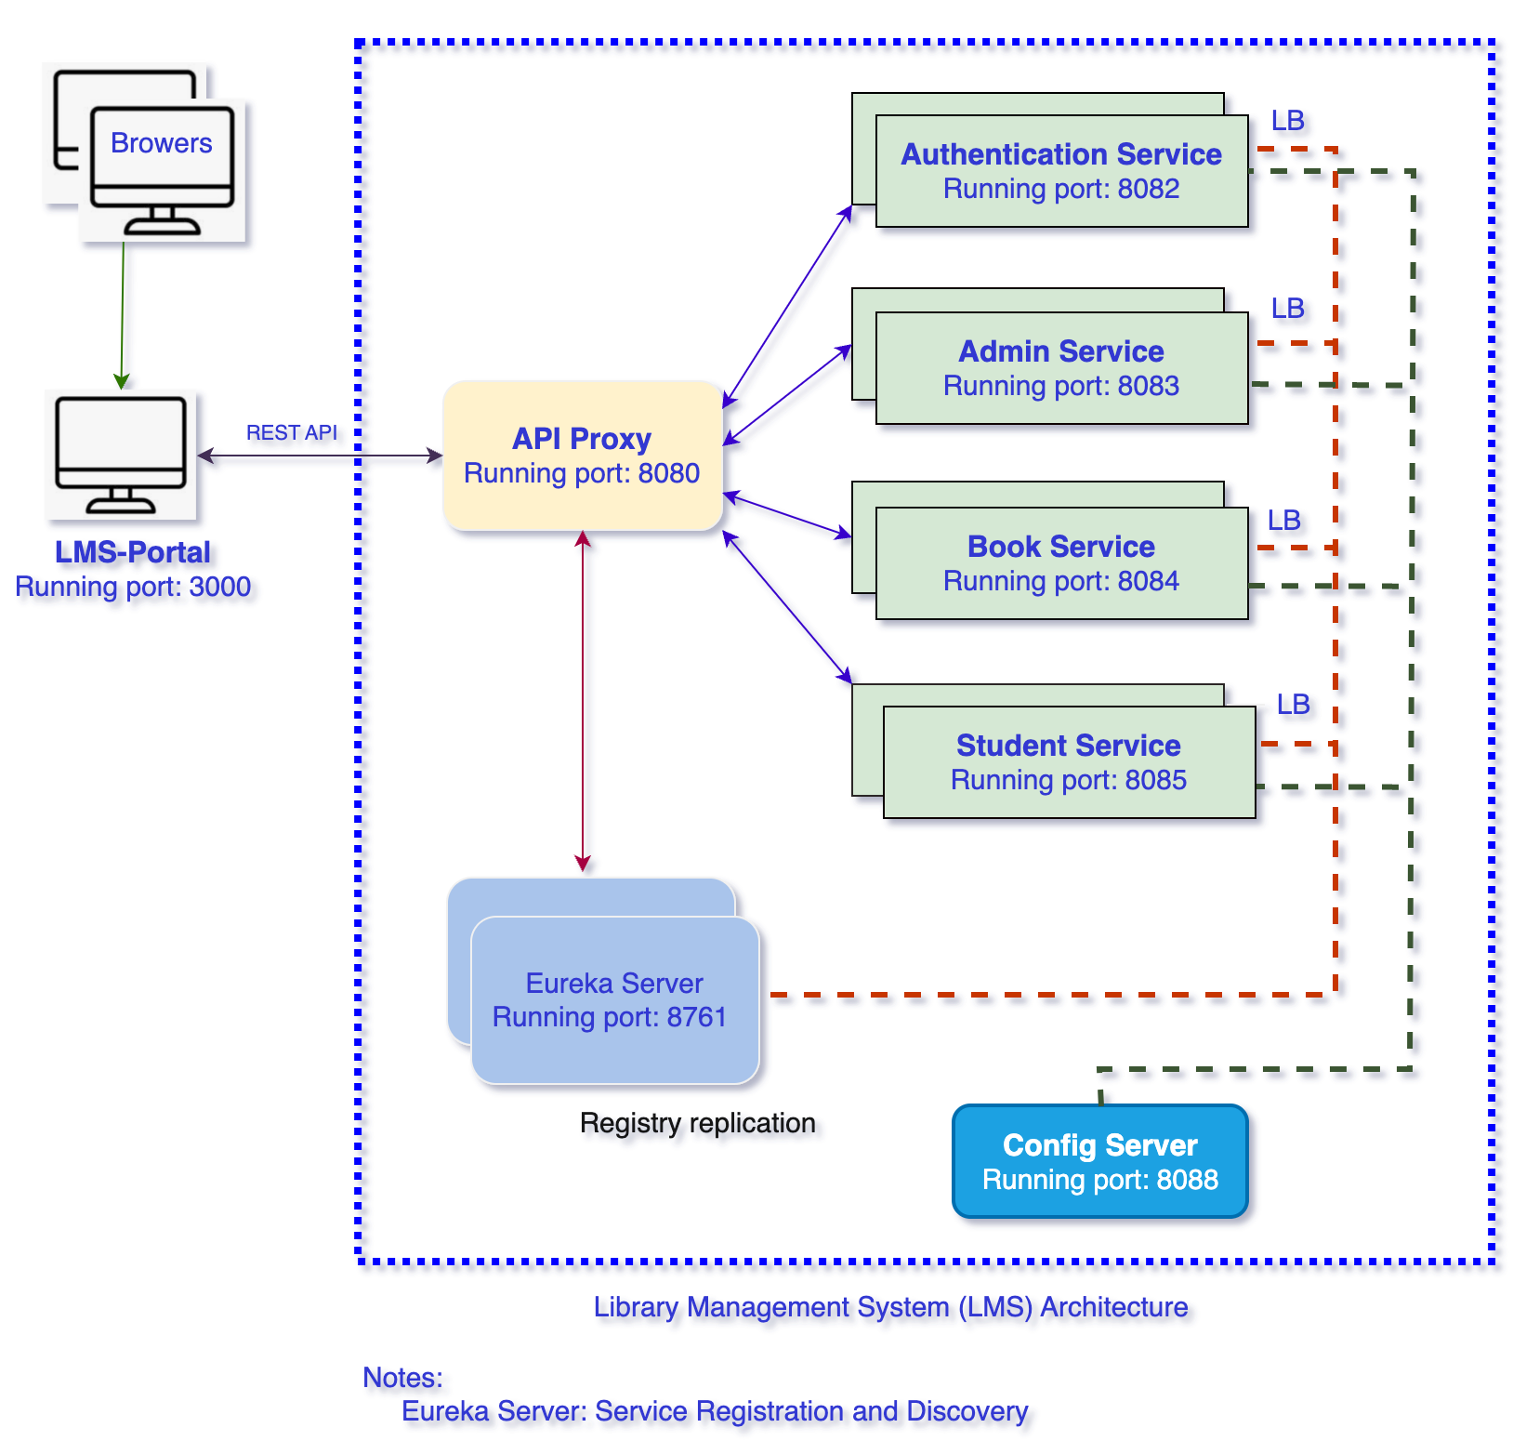

1. **System components**:

There are 8 components as following:

* LMS-Portal: containing user interfaces, developed based on React
* LMS-Auth: containing the authentication services: login, logout, verify token…
* LMS-Server: containing service registration and discovery based on Spring cloud
* LMS-Gateway: containing the routing service based on the URL predicates
* LMS-Config: containing the configuration of all services
* LMS-Admin: containing the administration operations for book categories, book, users…
* LMS-Book: containing the book services: check-in, check-out, list checkout records…
* LMS-Student: containing the student services: register, list checkout records, update profiles…

1. **REST API Specification**: refer to REST-API-Specification.md file
2. **Screenshots**
3. Home page

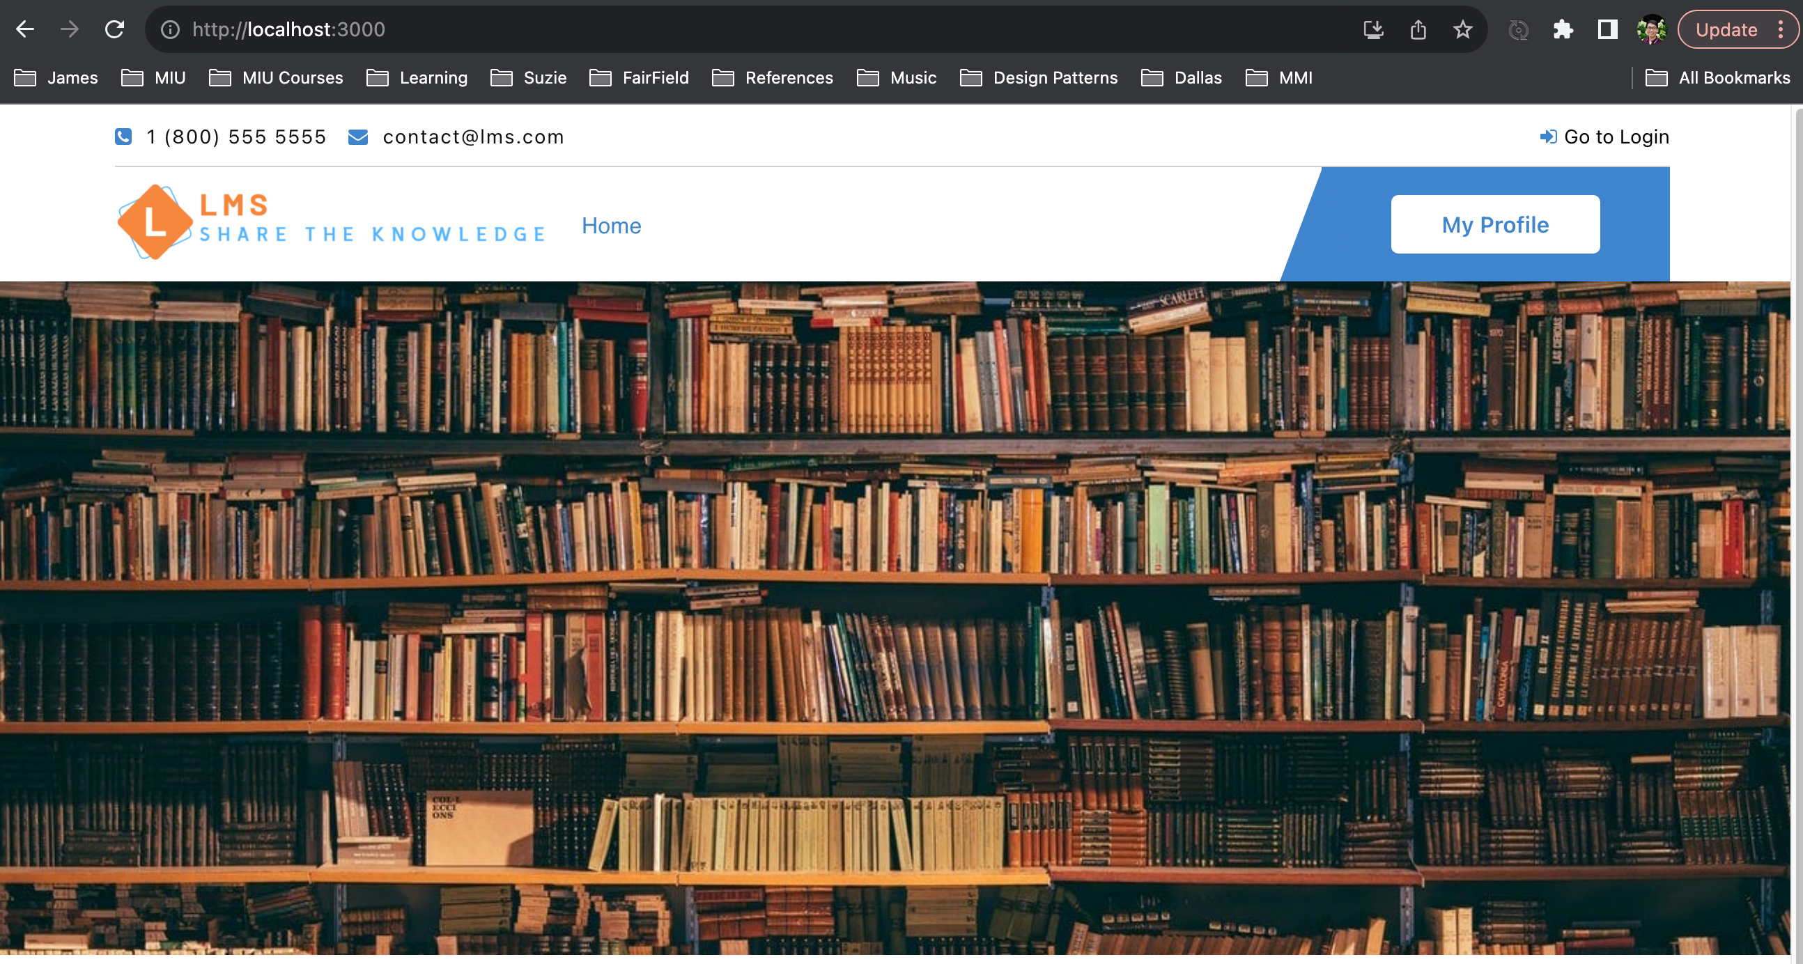

1. Login Page

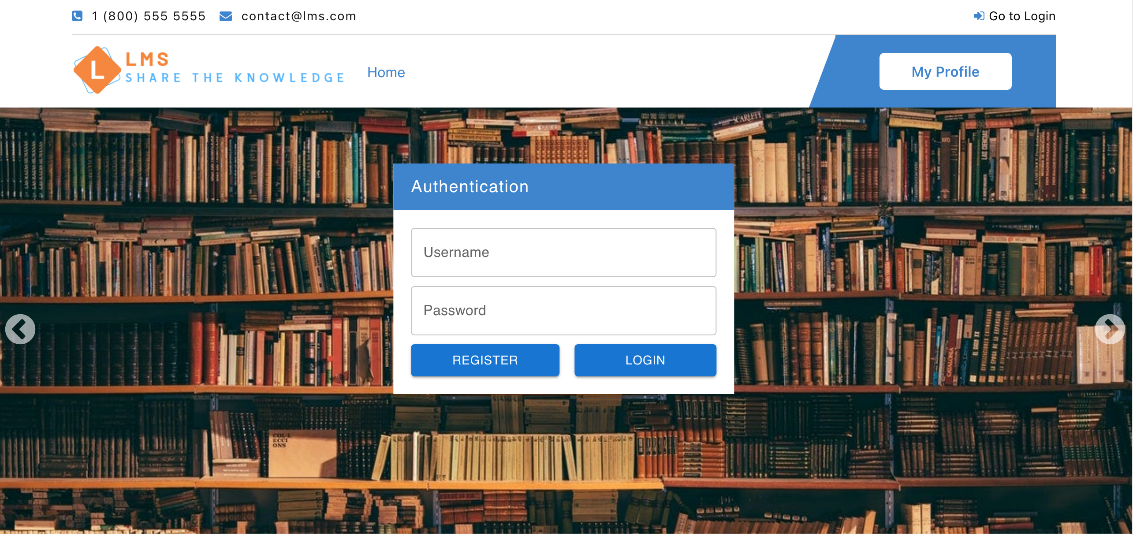

1. Admin - main page



1. Admin - manage users

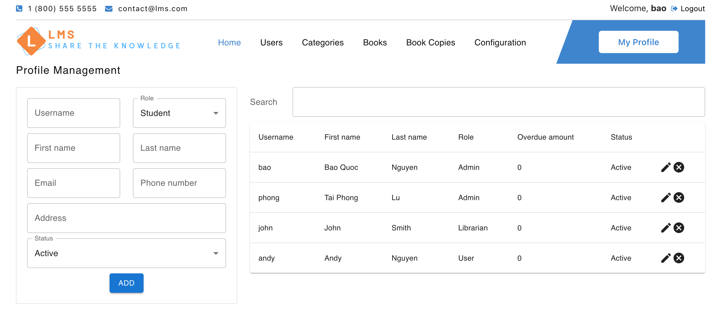

1. Admin – manage book categories

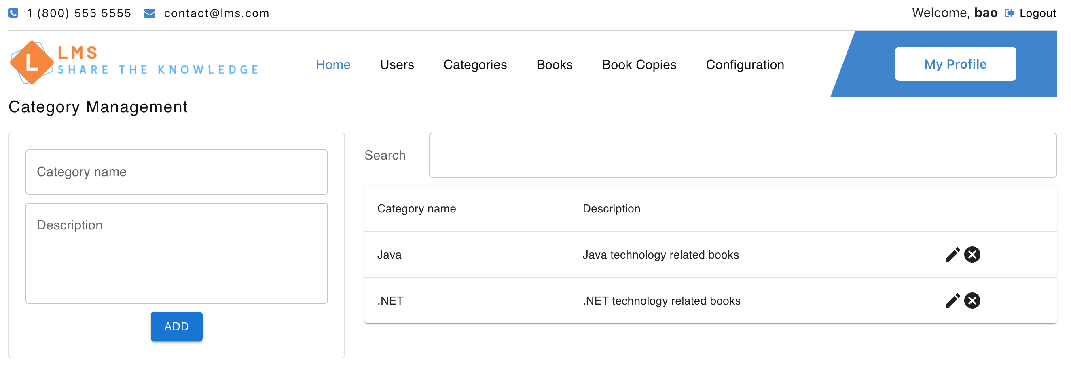

1. Admin – manage book

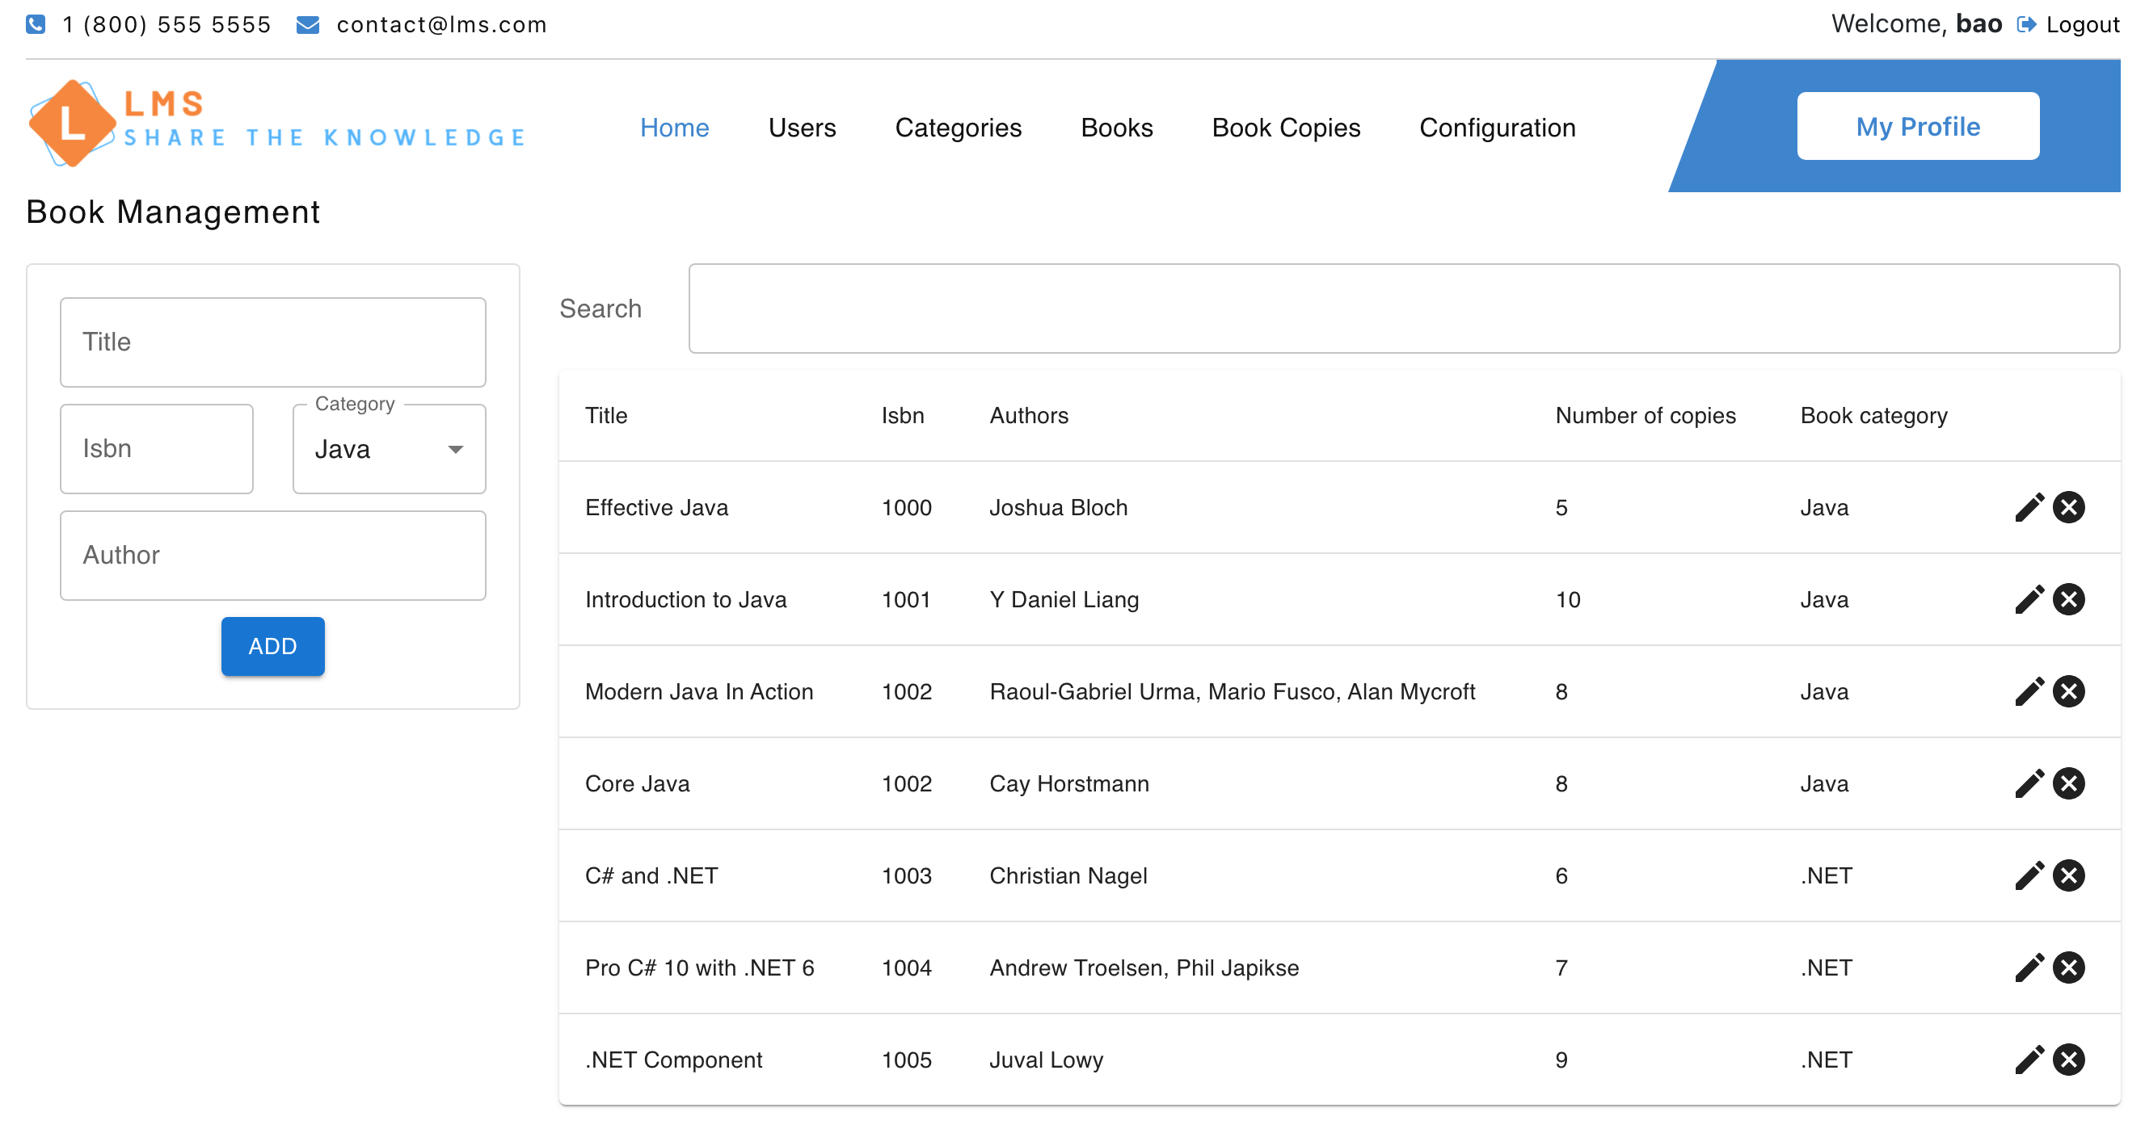

1. Admin - manage book copies

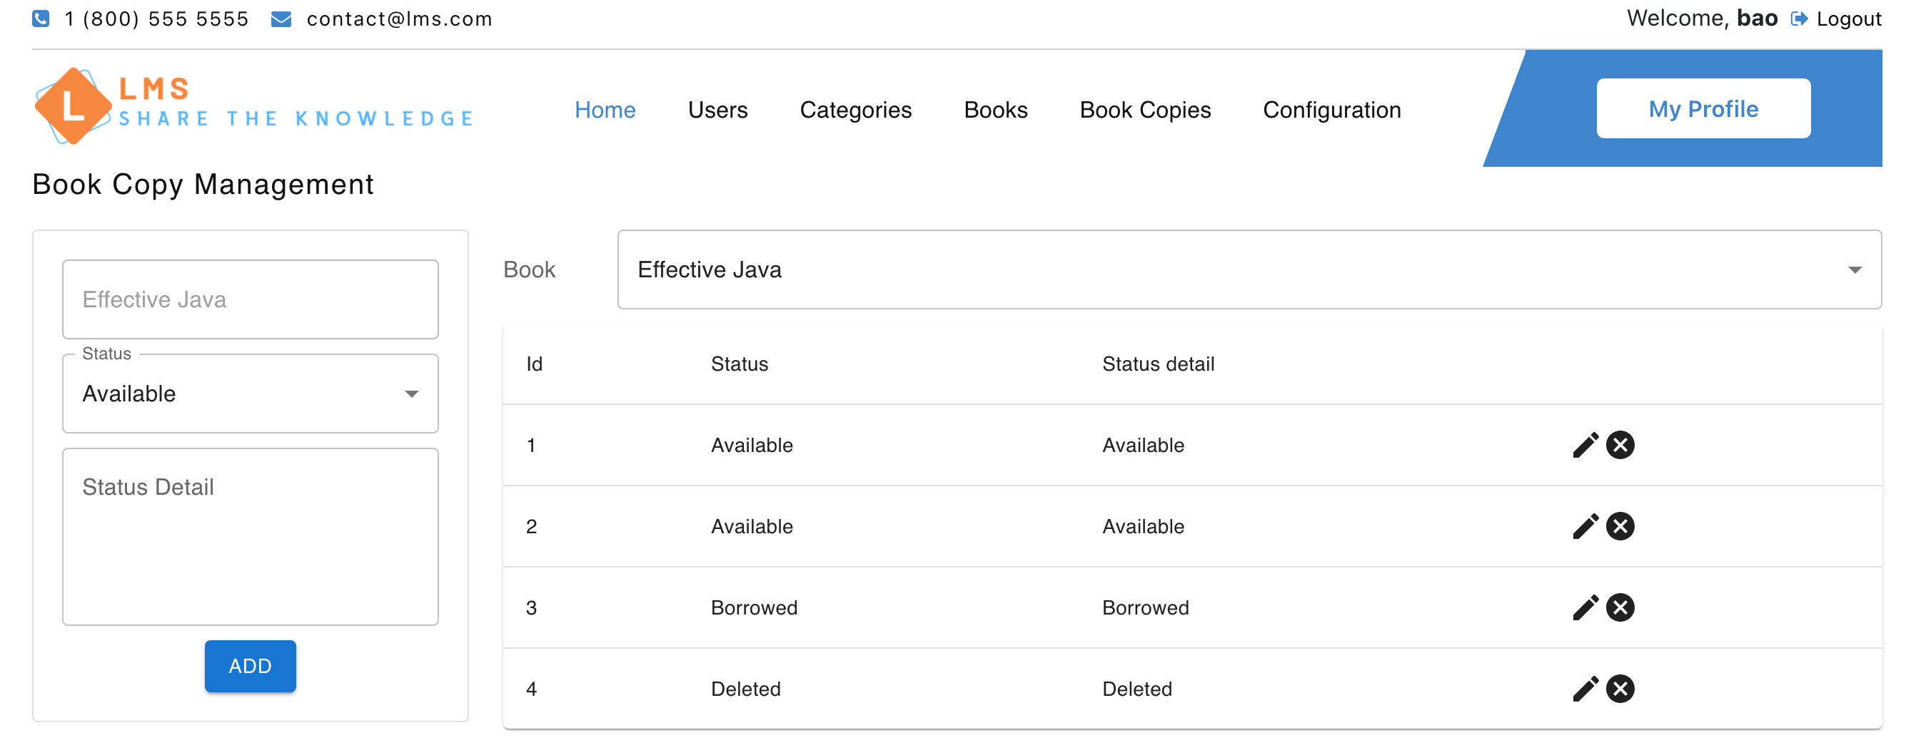

1. Admin – manage system configuration

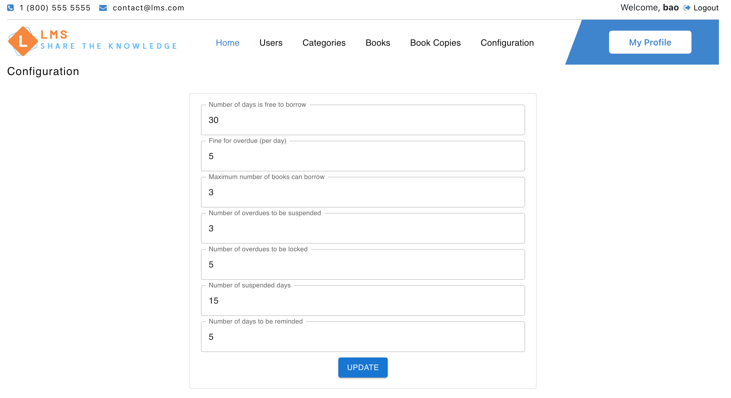

1. Admin – update profile

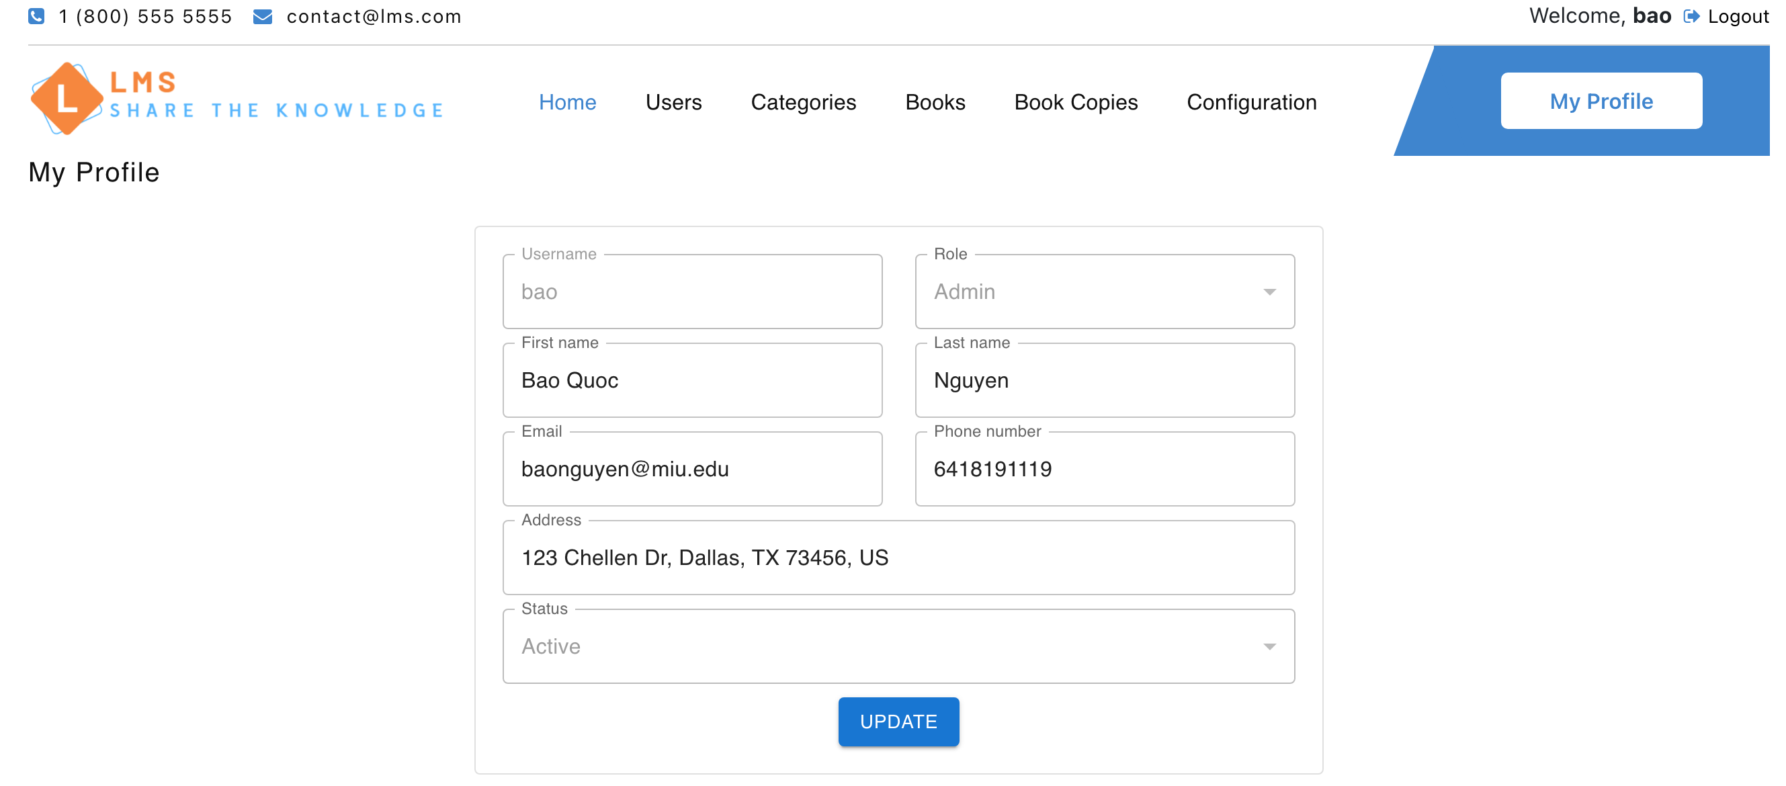

1. Library – main page



1. Librarian – Check-out page

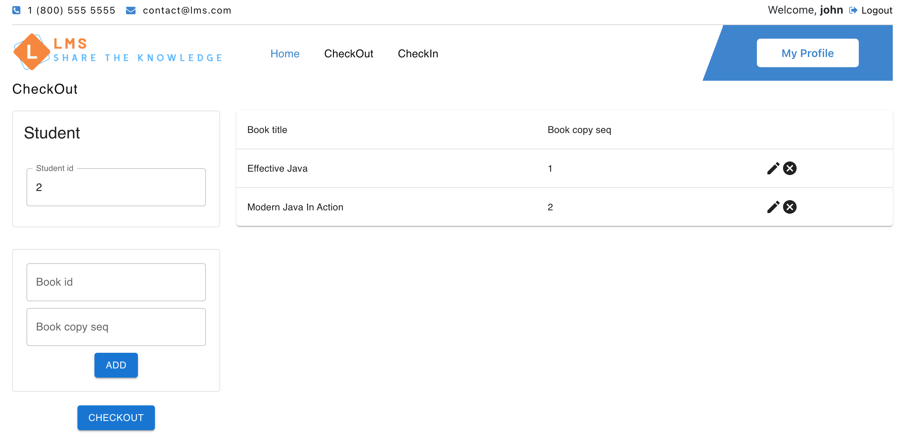

1. Librarian – Check-in page

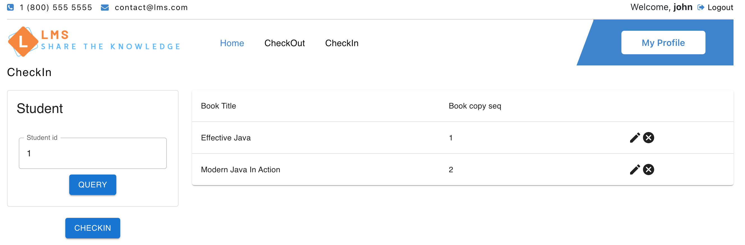

1. Librarian – update profile

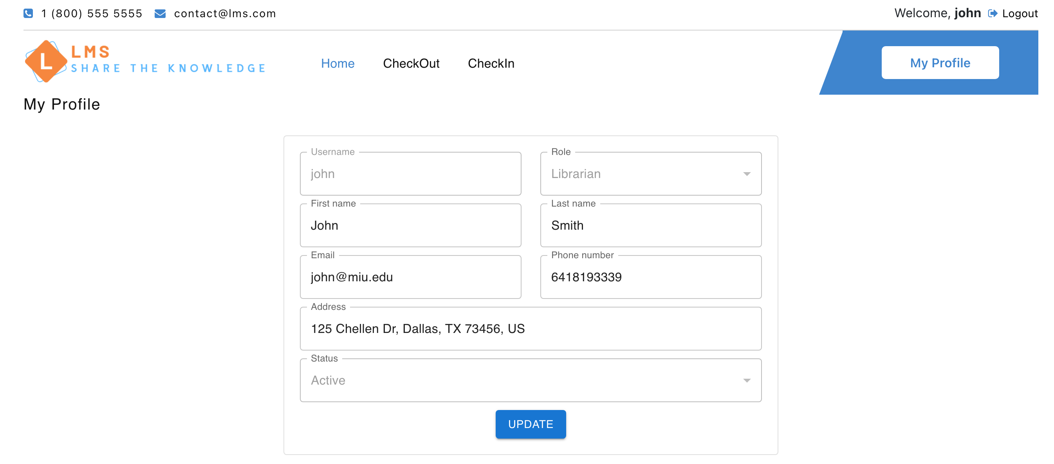

1. Student – main page



1. Student – checkout records

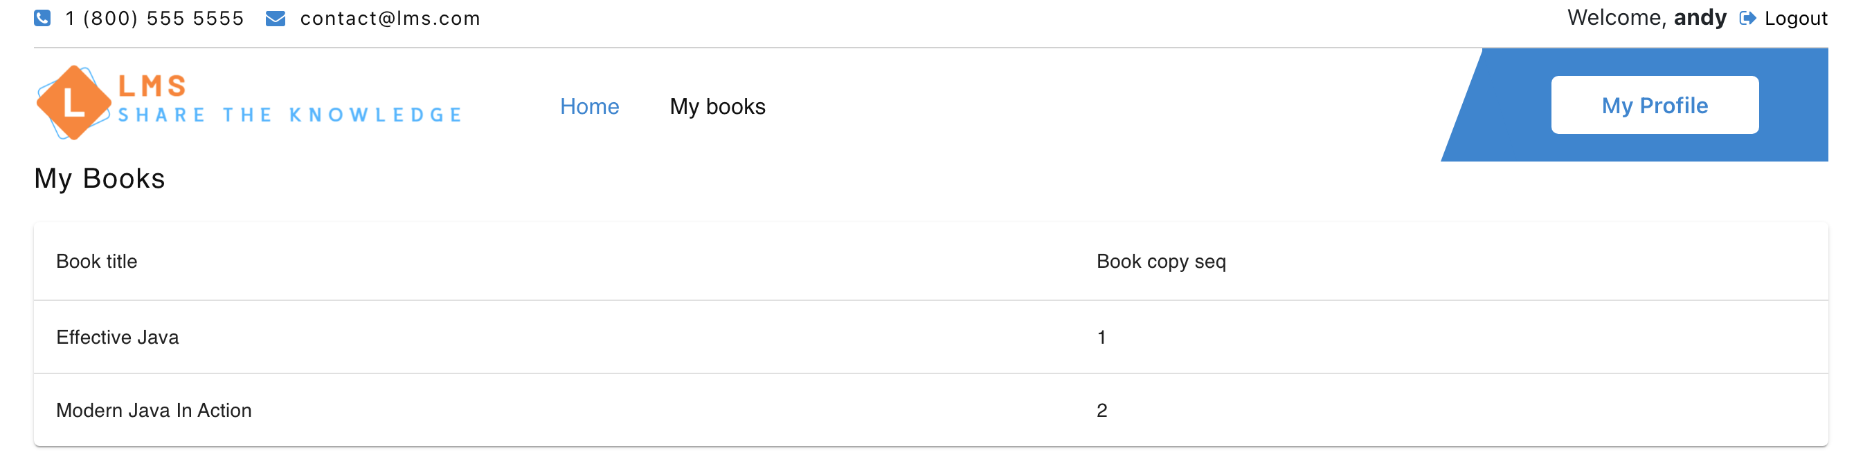

1. Student – update profile

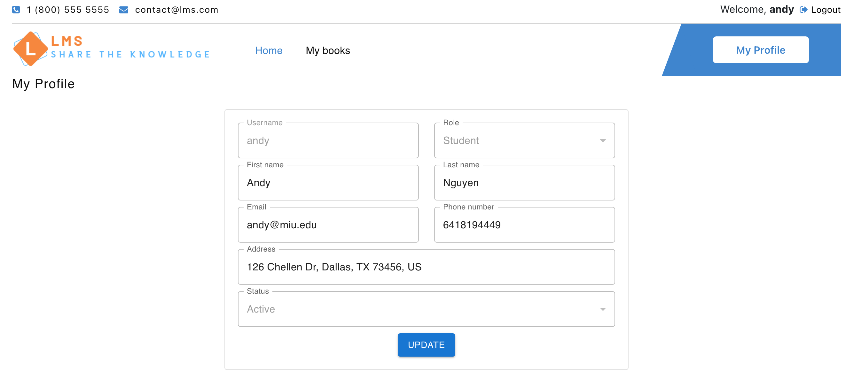

1. **Databases**
2. Admin service database

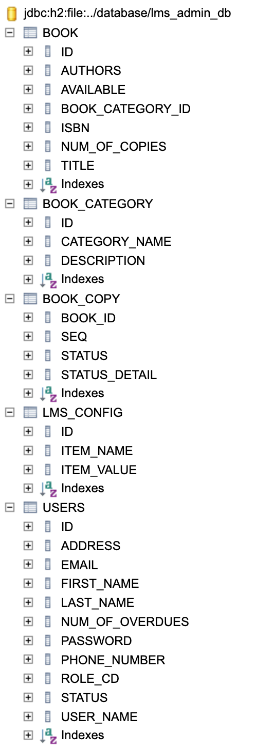

1. Book service database

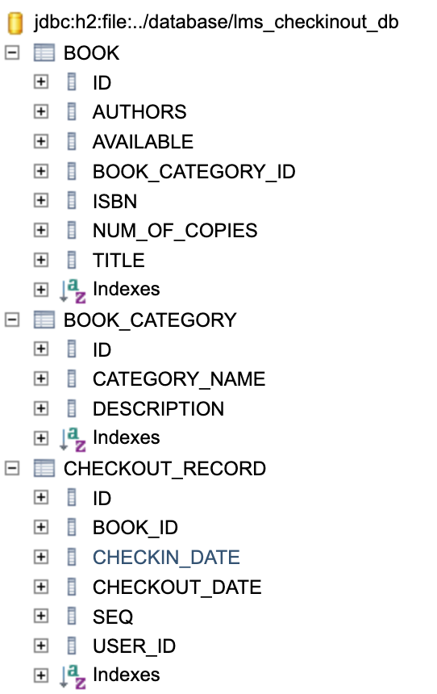

1. **Test cases**: are implemented in the corresponding test package of every service
2. **Git repository**: https://github.com/phonglu-miu-edu/CS425-SE-Project